**Sales Performance Analysis**:

* This report analyses product sales across different product categories in two regions (East and West), with a certain number of famous cities in both regions of the USA.
* This report shows us the comparison of sales of products in two different regions.
* This report also shows us what are the most popular product in two regions.
* Through this report we can see the favourite category amongst all is Cookies with highest revenue in both regions.
* It also tells us which product is least favourite along with its unit price and quantity sold in different regions.
* Potato chips are the least favourite with total lowest revenue product in both regions.
* Product with Highest sales revenue in East and west region.
* It shows us the Popular product (i.e. carrot Bars) in Boston city.
* This report also gives a data about the number of transactions been made on particular day of a month or in a month.

1. What is the total revenue generated from selling Carrot Bars in the East region?

Answer -

|  |  |
| --- | --- |
|  | **Region** |
| **Category** | **East** |
| Bars | 4249.7 |

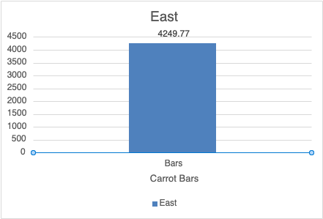

1. How many units of Whole Wheat Crackers were sold in the Boston city?

|  |  |
| --- | --- |
|  | **City** |
| **Product** | **Boston** |
| Whole wheat Crackers | 726 |
| **Grand Total** | **726** |

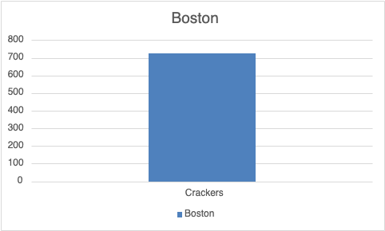

1. What is the average quantity of Chocolate Chip Cookies sold in the West region?

|  |  |
| --- | --- |
| **Average of Qty** | **Region** |
| **Choco Chip** | **West** |
| Cookies | 74.1 |
| **Average Total** | **74.1** |

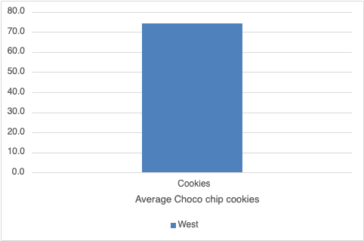

1. Which city has the highest sales of Arrowroot Cookies?

|  |  |  |  |  |
| --- | --- | --- | --- | --- |
| **Choco Chip** | **City** |  |  |  |
| **Category** | **Boston** | **Los Angeles** | **New York** | **San Diego** |
| Cookies | 1918.4 | 403.3 | 2025.22 | 983.18 |
| **Total Sales** | **1918.4** | **403.3** | **2025.22** | **983.18** |

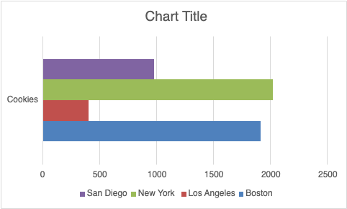

1. What is the highest-selling product in the New York city?

|  |  |
| --- | --- |
|  | **City** |
| **Product** | **New York** |
| Arrowroot | 2025.22 |
| Bran | 1052.81 |
| Carrot | 1982.4 |
| Chocolate Chip | 878.9 |
| Oatmeal Raisin | 1297.88 |
| Potato Chips | 529.53 |
| Whole Wheat | 492.09 |

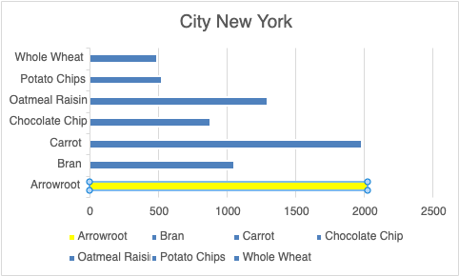

1. What is the total revenue generated from selling Potato Chips in the East region?

|  |  |
| --- | --- |
|  | **Product** |
| **Region** | **Potato Chips** |
| East | 873.93 |
| **Total Revenue** | **873.93** |

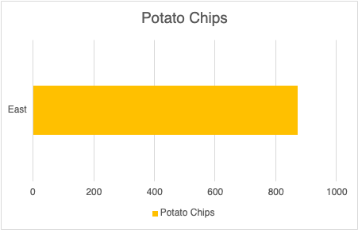

1. How many units of Bran Bars were sold in the West region?

|  |  |  |
| --- | --- | --- |
|  |  | **Region** |
| **Product** | **Category** | **West** |
| **Bran** | **Bars** | **545** |
| **Total Units** |  | **545** |

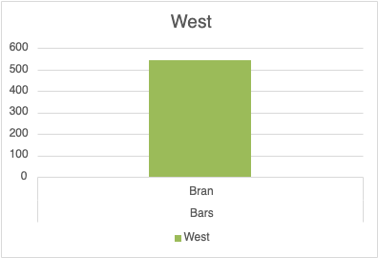

1. What is the most popular category of products in the Boston city?

|  |  |  |
| --- | --- | --- |
| **Category** | **Product** | **Boston** |
| **Bars** | Banana | 79 |
|  | Bran | 467 |
|  | Carrot | 1281 |
| **Bars Total** |  | **1827** |
| **Cookies** | Arrowroot | 880 |
|  | Chocolate Chip | 642 |
|  | Oatmeal Raisin | 1184 |
| **Cookies Total** |  | **2706** |
| **Crackers** | Whole Wheat | 726 |
| **Crackers Total** |  | **726** |
| **Snacks** | Potato Chips | 205 |
|  | Pretzels | 186 |
| **Snacks Total** |  | **391** |
| **Total** |  | **5650** |

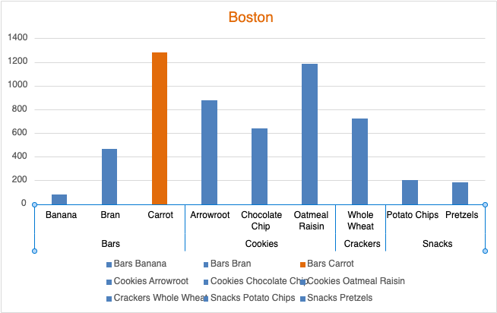

1. Which product had the highest revenue generated in the East region?

|  |  |
| --- | --- |
|  | **Region** |
| **Product** | **East** |
| Arrowroot | 3943.62 |
| Banana | 179.33 |
| Bran | 1926.1 |
| Carrot | 4249.77 |
| Chocolate Chip | 2079.44 |
| Oatmeal Raisin | 4660.44 |
| Potato Chips | 873.93 |
| Pretzels | 585.9 |
| Whole Wheat | 3025.83 |
| **Total** | **21524.36** |

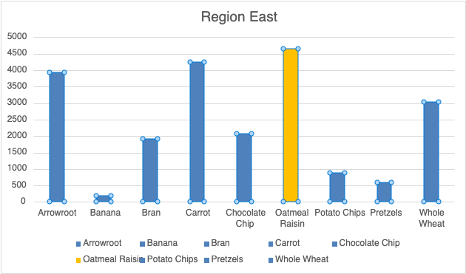

1. What is the average unit price of products in the West region?

|  |  |
| --- | --- |
| **Average UnitPrice** | **Region** |
| **Product** | **West** |
| Arrowroot | $2 |
| Bran | $2 |
| Carrot | $2 |
| Chocolate Chip | $2 |
| Oatmeal Raisin | $3 |
| Potato Chips | $2 |
| Whole Wheat | $3 |
| **Average Total** | **$2** |

1. How many transactions occurred on the 1st of each month?

|  |  |
| --- | --- |
| **Month** | **Count of ID** |
| Jan | 1 |
| Apr | 2 |
| May | 1 |
| Jun | 1 |
| Jul | 1 |
| Sep | 1 |
| Oct | 1 |
| Nov | 1 |
| Dec | 1 |
| **Total Transactions** | **10** |

1. Which product had the lowest revenue generated across all regions?

|  |  |
| --- | --- |
| **Product** | **Min of Total Price** |
| Arrowroot | 43.6 |
| Banana | 49.94 |
| Bran | 48.62 |
| Carrot | 35.4 |
| Chocolate Chip | 43.01 |
| Oatmeal Raisin | 82.36 |
| Potato Chips | 33.6 |
| Pretzels | 66.15 |
| Whole Wheat | 69.8 |

1. What is the total revenue generated from selling Oatmeal Raisin Cookies in the East region?

|  |  |  |
| --- | --- | --- |
|  |  | **Region** |
| **Product** | **Category** | **East** |
| **Oatmeal Raisin** | Cookies | 4660.44 |
| **Grand Total** |  | **4660.44** |

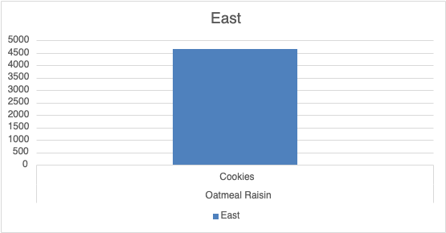

1. How many transactions took place in the West region?

|  |  |
| --- | --- |
| **Region** | **Count of ID** |
| West | 94 |
| **Total Transactions** | **94** |

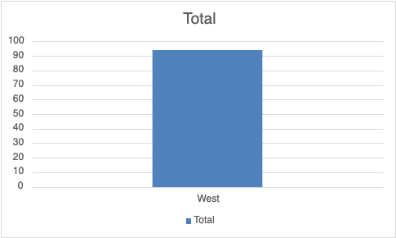

1. Which category had the highest revenue generated in the Los Angeles city?

|  |  |
| --- | --- |
| **Category** | **Revenue** |
| Bars | $541.6 |
| Cookies | $817.9 |
| Crackers | $73.3 |
| Snacks | $191.5 |
| Max Revenue price | $817.9 |

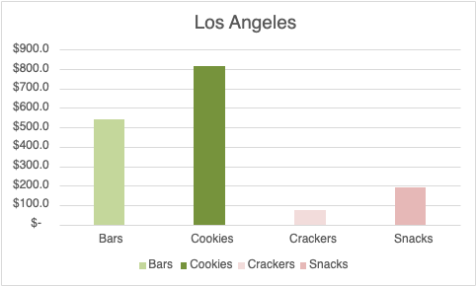

1. What is the average total price of products in the New York city?

|  |  |
| --- | --- |
|  | **City** |
| **Product** | **New York** |
| Arrowroot | $337.5 |
| Bran | $117.0 |
| Carrot | $116.6 |
| Chocolate Chip | $109.9 |
| Oatmeal Raisin | $162.2 |
| Potato Chips | $58.8 |
| Whole Wheat | $98.4 |
| **Average of Total price** | **$142.9** |

1. How many units of Carrot Bars were sold on the 31st of January?

Zero

1. Which product had the highest revenue generated in the Los Angeles city?

|  |  |
| --- | --- |
| **Product** | **Los Angeles** |
| Arrowroot | $403.3 |
| Bran | $652.6 |
| Carrot | $2,233.7 |
| Chocolate Chip | $1,565.2 |
| Oatmeal Raisin | $2,076.0 |
| Potato Chips | $609.8 |
| Whole Wheat | $146.6 |
| **Max Price** | **$2,233.7** |

1. What is the total revenue generated from selling Chocolate Chip Cookies across all regions?

|  |  |
| --- | --- |
|  | **Category** |
| **Product** | **Cookies** |
| Chocolate Chip | 4572.15 |
| **Region Total** | **4572.15** |

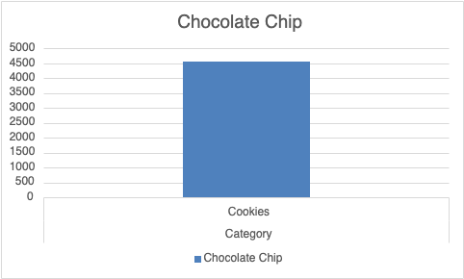

1. How many transactions involved selling products from the Snacks category?

|  |  |
| --- | --- |
|  | **Snacks category** |
| **Count of ID’s** | **29** |

1. Which category has the highest average quantity sold in the East region?

|  |  |  |
| --- | --- | --- |
| **Region** | **Category** | **Average of Qty** |
| **East** | Bars | £63.8 |
|  | Cookies | £84.5 |
|  | Crackers | £39.4 |
|  | Snacks | £37.7 |
| Max Average Quantity |  | $84.5 |

1. What is the lowest unit price for any product in the dataset?

|  |  |
| --- | --- |
| **Product** | **Min of Unit Price** |
| Arrowroot | 2.18 |
| Banana | 2.27 |
| Bran | 1.87 |
| Carrot | 1.77 |
| Chocolate Chip | 1.87 |
| Oatmeal Raisin | 2.84 |
| Potato Chips | 1.35 |
| Pretzels | 3.15 |
| Whole Wheat | 3.49 |
| **Min Unit price** | **1.35** |

1. How many transactions took place in the month of February?

|  |  |
| --- | --- |
| **Month** | **Count of ID** |
| Feb | 28 |
| **Transactions** | **28** |

1. What is the total revenue generated from selling products with a unit price greater than $2.50?

Formula used on whole table to get the total revenue generated from products with unit price higher than 2.50. :- =Sumif(I:I,”>2.50”,J:J)

11235.99

1. How many units of Whole Wheat Crackers were sold on the 22nd of January?

Zero

1. Which product had the highest revenue generated in the month of February?

|  |  |  |
| --- | --- | --- |
| **Month** | **Product** | **Sum of Total Price** |
| **Feb** | Arrowroot | 1242.6 |
|  | Bran | 435.71 |
|  | Carrot | 771.72 |
|  | Chocolate Chip | 516.12 |
|  | Oatmeal Raisin | 1161.56 |
|  | Potato Chips | 85.17 |
|  | Whole Wheat | 167.52 |
| Max Revenue Product |  | 1242.6 |

1. What is the average revenue per transaction in the Boston city?

|  |  |
| --- | --- |
| **City** | **Average of Total Price** |
| Boston | 150.75 |
| **Grand Total** | **150.75** |

1. *Which region had the highest sales of Arrowroot Cookies*

|  |  |  |
| --- | --- | --- |
| **Region** |  | **Arrowroot COOKIES** |
| East |  | 3943.62 |
| West |  | 1386.48 |
| **Grand Total** |  | **5330.1** |

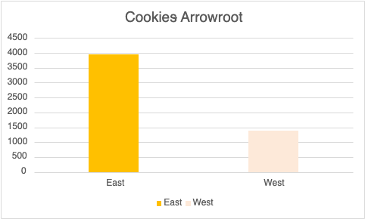

1. What is the total revenue generated from selling products with a quantity greater than 50 units?

Used SumIF formula = SUMIF(H:H,”>50”,J:J)

Total revenue generated from selling products with quantity greater than 50 units is

|  |
| --- |
| 23458.28 |

1. How many transactions involved selling products with a total price greater than $100?

Used Countif Formula on total price column = CountIF(J:J,”>100”)

Number of Transactions selling product greater than $100 price are 125